COS20019 – Cloud Computing Architecture

ACF Lab 5: RDS Lab

Do Duy Hung  
Student ID: 104182779  
Date:4/2/2024

# Introduction (*Heading 1*)

Amazon Relational Database Service (RDS) is a cloud-based database service offered by Amazon Web Services (AWS) that simplifies the setup, operation, and scaling of relational databases. RDS supports several database engines, including MySQL, PostgreSQL, Oracle, SQL Server, and MariaDB, allowing users to choose the one that best fits their application requirements. With RDS, users can offload database management tasks such as backups, software patching, and scaling, allowing them to focus more on developing applications and less on infrastructure maintenance. RDS offers high availability through automatic backups, automated software patching, and the option to deploy databases across multiple Availability Zones for enhanced reliability. Additionally, it provides security features such as encryption at rest and in transit, making it a convenient and secure solution for managing relational databases in the cloud.

# Ease of Use

## Task 1: Create a Security Group for the RDS DB Instance

4, Select VPC from the Services

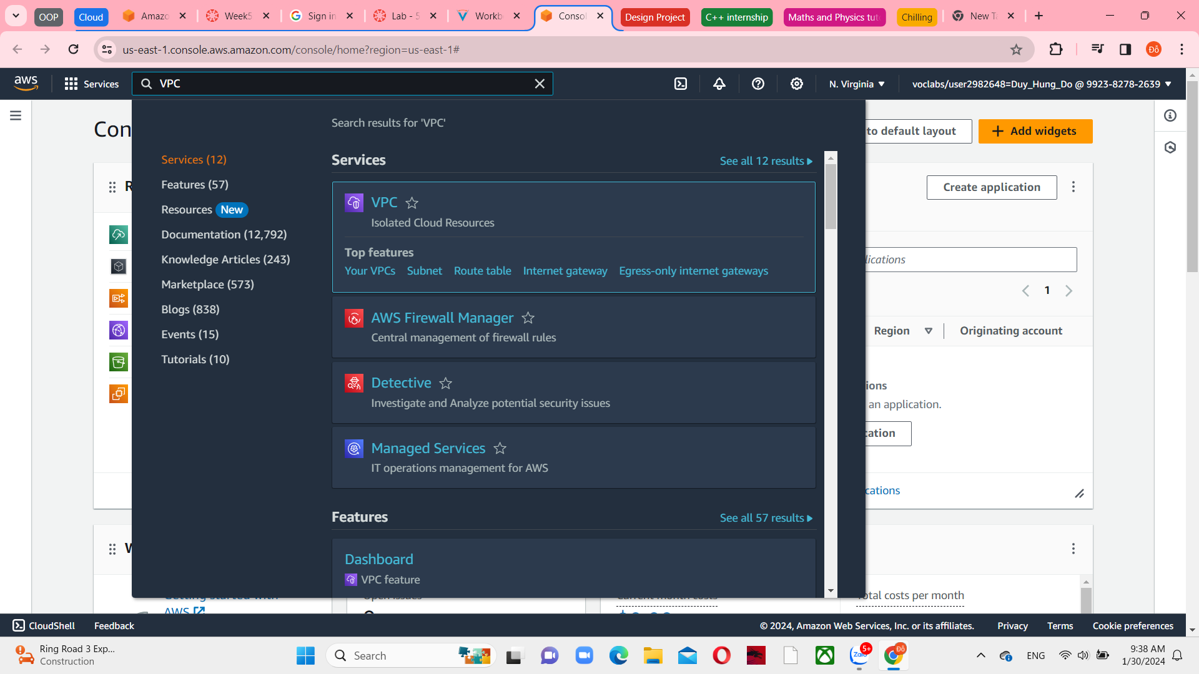  
 Firgue1 – VPC selection

5, Choose Security groups in the left navigation pane

Firgue2 – Security groups main menu

6, Create security groups with this information:

* Security group name: DB Security Group
* Description: Permit access from Web Security Group
* VPC: Lab VPC

Firgue3 – Create Security Group

7, Add rule with MySQL type and Web Security Group resources

Firgue4 – Inbound rules

9, And then, create a security group

Firgue5 – Create security group successfully

## Task 2: Create a DB Subnet Group

11, Select RDS from Services

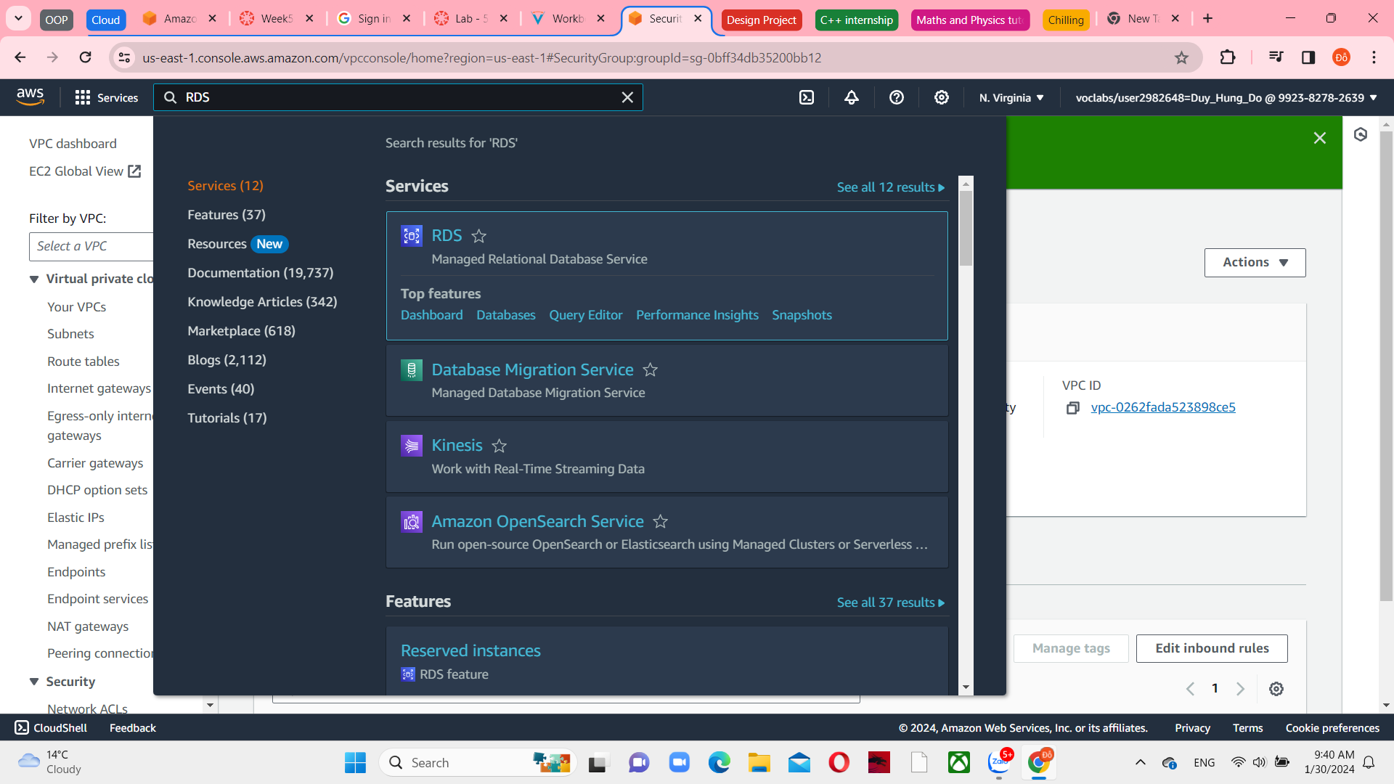

Firgue5 – RDS selection

12, Create DB Subnet Group with this following information:

* Name: DB-Subnet-Group
* Description: DB Subnet Group
* VPC: Lab VPC

Firgue6 – Subnet groups main menu

Firgue7 – Subnet Group details

13, In the Add Subnets section, select the CIDR ranges 10.0.1.0/24 for us-east-1a and 10.0.3.0/24 for us-east-1b

Firgue8 – Add subnets

And then, create them

Firgue9 – Successfully creation subnet groups

## Task 3: Create an Amazon RDS RB Instance

17, Choose Databases in left navigation pane and create the databases.

Firgue9 – Create new databases

19, In Engine Options, select MySQL

Firgue11 – MySQL in Engine Options

21, Choose Dev/Test under Templates

Firgue12 – Templates

21, Choose Multi-AZ DB instance under Availability and durability

Firgue13 – Output details tab

22, In Settings, configure:

* DB instance indentifier: lab-db
* Master username: main
* Master password: lab-password
* Confirm password: lab-password

Firgue14 – Change settings

23, Under DB instance class, configure:

* Burstable class (include t classes)
* Select db.t3.micro

Firgue15 – Instance configuration

24, Under Storage choose:

* Storage type: General Purpose (SSD), gp2 or gp3 is ok
* Allocated storage: 20

Figure17- Storage

25, Choose Lab VPC in Connectivity

Firgue18 – Connectivity

26, Under Existing VPC security groups:

* Choose DB Security Group
* Deselect default

Firgue 18 - Existing VPC security groups

27, Uncheck Enable Enhanced monitoring, Enable automatic backups and Enable encryption with the database name “lab”

Firgue19 – Monitoring

Firgue19 – Enabled status

29, And them, create Database

Firgue20 – Successfully creation the database

30, Wait approximately 4 minutes until Modifying status and choose lab-db, scroll down to Connectivity and security section and copy the Endpoint field to a text editor

Firgue21 – Connectivity and Security

## Task 4: Interact with Your Database

34, If you want to copy IP address, choose EC2 and select running instance is “Web Server”

Firgue22 – EC2 instance menu

36, Paste the IP address to other web browsers and choose the RDS link at the top right of the page

Firgue23 – AWS databases

37, Configure the following settingsL

* Endpoint: the aws link you copied before
* Database: lab
* Username: main
* Password: lab-password

And then submit. You can see 2 Address Book.

Figure24 – RDS links

Figure 25- Address Book